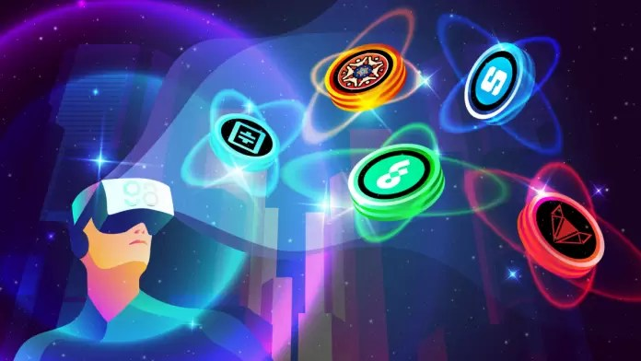

**What Is The Metaverse?**

* In its digital iteration, a metaverse is a virtual world based on blockchain technology. This all-encompassing space allows users to work and play in a virtual reflection of real-life and fantasy scenarios, an online reality, ranging from sci-fi and dragons to more practical and familiar settings like shopping centers, offices, and even homes.
* Users can access metaverses via computer, handheld device, or complete immersion with a VR headset. Those entering the metaverse get to experience living in a digital realm, where they will be able to work, play, shop, exercise, and socialize. Users will be able to create their own avatars based on face recognition, set up their own businesses of any kind, buy real estate, create in-world content and asset,s and attend concerts from real-world superstars—all in one virtual environment,
* With that said, a metaverse is a virtual world with a virtual economy. In most cases, it is an online reality powered by decentralized finance (DeFi), where users exchange value and assets via cryptocurrencies and Non-Fungible Tokens.

**What Are Metaverse Tokens?**

* Metaverse tokens are a unit of virtual currency used to make digital transactions within the metaverse. Since metaverses are built on the blockchain, transactions on underlying networks are near-instant. Blockchains are designed to ensure trust and security, making the metaverse the perfect environment for an economy free of corruption and financial fraud.
* Holders of metaverse tokens can access multiple services and applications inside the virtual space. Some tokens give special in-game abilities. Other tokens represent unique items, like clothing for virtual avatars or membership for a community. If you’ve played MMO games like World of Warcraft, the concept of in-game items and currencies are very familiar. However, unlike your traditional virtual world games, metaverse tokens have value inside and outside the virtual worlds. Metaverse tokens in the form of cryptocurrency can be exchanged for fiat currencies. Or if they’re an NFT, they can be used to authenticate ownership to tethered real-world assets like collectibles, works or art, or even cups of coffee.
* Some examples of metaverse tokens include SAND of the immensely popular Sandbox metaverse. In The Sandbox, users can create a virtual world driven by NFTs. Another token is MANA of the Decentraland project, where users can use MANA to purchase plots of digital real estate called “LAND”. It is even possible to monetize the plots of LAND purchased by renting them to other users for fixed fees. The ENJ token of the Enjin metaverse is the native asset of an ecosystem with the world’s largest game/app NFT networks.

**Dataset Information**

* The dataset brings 198 metaverse cryptos. Pls refer to the file Metaverse coins.csv to find the list of metaverse crypto coins.
* The dataset will be updated on a weekly basis with more and more additional metaverse tokens, Stay tuned ⏳